BURLIUK, DAVID (БУРЛЮК, ДАВИД, 1882 – 1967)

Deemed by many as the founding father of Russian FUTURISM, David Davidovich Burliuk was a painter, writer, poet, performance artist, journal editor, and publisher. Burliuk is considered to be a major figure of both the Russian and Ukrainian avant-garde movements. He began his artistic career in the first decade of the twentieth century at the Royal Academy in Germany and at L’ecole des beaux arts in France. He became famous in his homeland in 1912 when the Futurist manifesto *A Slap in the Face of Public Taste* was published at his initiative. The co-authors of this provocative text were Alexei Kruchenykh, Vladimir MAYAKOVSKY, and Velimir KHLEBNIKOV. Burliuk was instrumental in establishing the public stance of Russian Futurism by lecturing, performing and publishing multiple collections of art and poetry. The main heroic activities of the Russian Futurists orchestrated by Burliuk took place in the pre-war and inter-war period. After the Revolution Burliuk moved to the Far East, then to Japan, and eventually settled in the USA where he died at the age of 85.

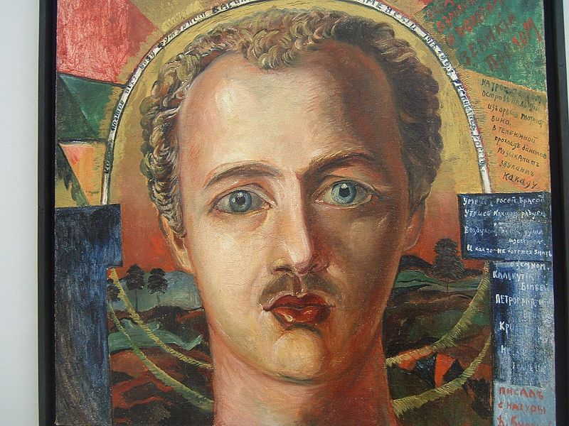

Portrait by Vassily Kamensky, 1916.

**Timeline of Life and Work**:

1882: Born in July, in a homestead Semirotovka (aka Semirotovschina) near Kharkov into the family of a well-to-do farmer. He lost an eye in his early childhood while fighting with one of his brothers. Burliuk had two brothers (Vladimir and Nikolai) and three sisters (Liudmila, Marianna, and Nadezhda).

1892: Starts his independent painting studies.

1897: Writes first poem.

1898-1899: Enrols in Kazan and Odessa State Colleges of painting.

1899: His first youthful poems published in a Ukrainian newspaper “Iug” (“South”).

1902-1905: Studies painting at the Royal Academy of Art in München and in Paris at L’ecole des beaux arts. Meets Konstantin Balmont, Maximillian Voloshin, and other prominent figures of new Russian art.

1907: Burliuk’s family moves to a landed property Chernodlinnoe, a manor owned by prince A.Mordvinoff where Burliuk’s father was hired as a chief caretaker.

1908: Organizes the *Link* (*Zveno*) exhibition in Kiev, accompanied by Burliuk’s first manifesto.

1909: Graduated from the Odessa College of Art.

1910: Enrols in the Moscow Academy of Fine Art (*Moscow Institute of Painting, Sculpture, and Architecture*). Starts organizing the activities of the Russian Futurist circle, known as “budetliane”. The first official name of the group was Hylea: an ancient toponym of the Ukrainian province where Burliuk’s home-farm was situated.

1910: First Hylea Futurist collection is published under the title *Sadok Sudei* (*A nurse pond of judges* / *A trap for judges*).

1911: Meets Mayakovsky who studied at the same Academy *(Moscow Institute of Painting, Sculpture, and Architecture*) in Moscow.

1912: The Futurist manifesto, *A Slap in the Face of Public Taste,* is published.

1913 – 1914: Various Futurist collections are published under Burliuk’s editing and illustration: *Croaked Moon* (*Dokhlaia luna*): *An Anthology of the Only Futurists in the World* (*Sbornik edinstvennych futuristov v mire*), *Spigot* (*Zatychka*), *A Breviary (Missal) of the Three* (*Trebnik troikh*), *Roaring Parnassus* (*Rykaiuschij Parnas*), *The First Journal of Russian Futurists* (*Futuristy: Pervyi Zhurnal russkich futuristov*).

1914: Departs for an extensive lecture tour across Russia.

1914: The Moscow Academy of Fine Art expels both Burliuk and Mayakovsky.

1915: Publishes a collection: *A Spring counter-agency of muses* (*Vesennee kontragentstvo muz*).

1916: Publishes a collection *The four birds* (*Chetyre ptizy*).

1916-1917: During the war years Burliuk lives in the Urals near the city of Ufa and works at various industries.

1918: Publishes a collection *Lyseiuschij Khvost* (*Balding tail*) (published in Kurgan).

1918: Took part in the final *Jack of Diamonds* *(Bubnovyj Valet*) exhibition (also participated in their previous venues in 1910, 1912, 1913, 1916).

1918: Takes part in *Gazeta Futuristov* together with Mayakovsky.

1918-1919: Travels to Siberia, to Harbin, and to the Far East.

1920-1922: Lives and works in Japan.

1922: Burliuk settles in the USA.

1956: Visits the USSR twice in 1956 and 1965.

1967: Dies in Hampton Bays, Suffolk County, New York.

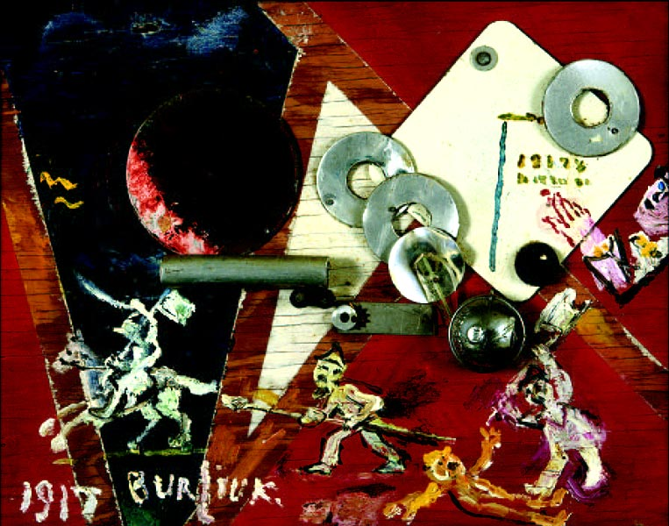

Revolution, 1917.

Festive Blue

*A green spirit flashed boldly like a stone*

*Into the lake's depth where mirrors dreamt.*

*Look now how brightly flared the flame*

*Where previously nestled the dim dark.*

*So heartless you in me awakened sorrow*

*Toward the water ghosts you'd demolished.*

*In that flash you wished to resist absence*

*Above the abyss that is a festive blue.*

1910

(Anthology of Russian Minimalist and Miniature Poems;

Part I, The Silver Age. Translated by Alex Cigale.)

David Davidovich Burliuk (1882-1967) is considered to be a major figure of both the Russian and Ukrainian avant-garde movements, as well as one of the founding members of Russian FUTURISM (together with Vladimir MAYAKOVSKY, Velimir KHLEBNIKOV, Alexey Kruchenykh and others). Burliuk’s open and often impetuous stance against the stifling official *peredvizhnik* [Russian Realist] ideology, and progressive political and artistic views earned him the title ‘father of Futurism’. This movement (Budetlianstvo) evoked a spirit of total experimentation, breaking the conventional rules of representation and vividly evoking the new technological age. The Father of Italian Futurism, F.T.MARINETTI, paid an important historical visit to Russia early in 1914. Although it was not well received, the Italian movement did indirectly influence the maturation of Russian Futurism. Prior to Marinetti’s visit, the Russian Futurists under David Burliuk’s leadership boldly acquired the name “Budetliane” (the Slavic etymological equivalent of “Futurists” playfully coined by Khlebnikov) and published their own manifesto in December 1912 entitled “A Slap in the Face of Public Taste,” which was partially reliant on audacious Italian Futurist proclamations. Burliuk’s larger outlook towards life’s improvement was informed by a desire to reform the tsarist autocracy, bureaucratic inefficiency, persecution and censorship in the Russian Empire.

Burliuk studied art in Kazan and Odessa between 1898 and 1901. He then traveled to Munich, where he studied with Wilhelm Diez at the Munich Art Academy in 1902 followed by Anton Azbe at his private school in 1903. In 1904, he studied at Fernand Cormon’s Academy in Paris. He returned to Ukraine, interested in the work of the impressionists and post-impressionists. He participated in the 17th and 18th exhibitions of the Association of South Russian [a term for Ukrainian during the Russian Empire] Artists in Odessa in 1906 and 1907. In 1907, Burliuk’s family moved to the estate of Count Alexander Mordvinov in Chernianka (known in Ukrainian as Chornianka), near Kherson in Southern Ukraine, where his father accepted a job as the estate’s manager. Its location near the mouth of the Dnieper River, in the historic lands of the ancient Scythes, became a rich source of inspiration for his artwork. Not only was Herodotus’ account of the Scythes in his *Histories* known to Burliuk, their artifacts were being excavated from mounds near the estate at the time, dating to 1000BC. Burliuk and his brothers worked on numerous such archeological digs, where they uncovered vases, goblets, jewelry, combs, scabbards, and other objects as well as skeletal remains. Some of the artifacts were housed at Chernianka, others at the nearby Kherson Museum.

Burliuk himself moved to Moscow in 1907, where a robust art community, international art exhibitions – particularly from Western Europe – provided a rich environment in which to work. There, he organized and participated in a number of exhibitions, several of them with his brother Vladimir, also an artist. In post-independence Ukraine, both David and Vladimir (Volodymyr in Ukrainian) have become important figures of a recuperated indigenous art history. The work of the Burliuk brothers was shown at the exhibitions Wreath-Stefanos, 1907; ‘Knave of Diamonds’, 1910; and ‘Exhibition of Painting 1915’. Outside Moscow, he featured his Symbolist *Blue Rose* group with Alexandra Exter, Natalya Goncharova, and Mikhail Larionov in the *Link* exhibition in Kyiv, 1908. He participated in the second and third exhibitions of the *Neue Künstlervereinigung München*, 1910 and 1911, respectively, in addition to contributing an essay - co-authored with his brother Vladimir - on Russian artists’ response to contemporary developments by the French avant-garde. He exhibited in Vladimir Isdebsky’s second salon in Odessa in 1911, and *Der Blaue Reiter* in 1911-12 in Munich in their first exhibition, with two neo-primitivist works. His essay ‘The ‘Savages’ of Russia” was published in *Der Blaue Reiter Almanach* (1912). From 1910 to 1913, he studied at the Moscow College of Painting, Sculpture and Architecture where he met the poet Vladimir Mayakovsky.

In 1910, Burliuk founded the major Futurist group known under the name of Hylea. The name, suggested by the fellow poet Benedikt Lifshitz, refers to the ancient name of the province of Scythia where Burliuk’s household was situated. The group included Velimir Khlebnikov, Vladimir Mayakovsky, Alexei Kruchenykh, Vasily Kamensky, and Elena Guro. Burliuk and the Futurists gained notoriety after the *Slap* manifesto appeared in 1912. Burliuk contributed to futurist booklets, *Roaring Parnassus* (1913), *Anthology of the Only Futurists in the World* (1914), *Balding Tale* (1918) as well as others. Under the editorship of Vasily Kamensky, he and the Russian futurists published the literary journal *Futuristy* (1914) surviving censorship for only two issues. In the following two years Burliuk helped to popularize Futurism by participating in what became known as “The Futurist Tour of Russia”. The tour included the two Burliuk brothers (David and Vladimir), as well as Mayakovsky and Kamensky. According to the “Futurist chronicle’” Burliuk visited about seventeen cities and towns of Russia presenting flamboyant Futurist events that included art exhibitions, poetry declamations and scandalizing lectures about the “new art”. At a certain point, David Burliuk started painting his face, orchestrating his appearance as a kind of theatrical performance. The idea behind it suggested that art must invade life with as much provocation as possible.

Artistically, Burliuk adhered to the belief that painting should capture life’s experiences, and interact with visual concerns of the day. His work in numerous artistic styles suggests his desire to embrace contemporary developments for their ability to affect change and new modes of thought, particularly in his early years. Burliuk’s landscape *Morning, Wind*, 1908 recalls the fine brushstrokes and viscous impasto associated with many of Van Gogh’s paintings, while *Cossack Mamai*, 1908 demonstrates a concern with fauvist color relationships and ethnographic Scythian sources. Similarly, he explored the relationship of planes and geometric forms through a cubo-futurist aesthetic in such paintings as *The Dancer*, 1910, and *Marriage Proposition*, 1910 [1962 repainted], followed by an exploration into Suprematism with the painting *Primavera*, 1913. Burliuk explained his artistic views frequently, in lectures at exhibition openings, and writings. His early, untitled essay for the second Neue Künstlervereinigung München exhibition catalogue – co-authored with his brother Vladimir – identified the trend for ethnographic source material within the European avant-garde, and a shared spirit between Russian and French artists. In “The Wild Savages” for the Blaue Reiter Almanach, Burliuk emphasized the belief in painting’s connection to life, and rejected the Russian Art Academy’s continued espousal of realism as the ideal mode of artistic expression. Burliuk’s essays, “Cubism (Surface – Plane)” and “Texture [Faktura]” appearing in *A Slap in the Face of Public Taste* (1912), continued to support contemporary developments, by focusing on the significance of painterly principles and visual elements as concrete vehicles for articulating higher ideas.

The Russian Futurists were led by the flamboyant figure of Burliuk to explore a radical agenda in their public activities, attempting to shock the middle class into social and political change. They mocked and rejected the most sacred Russian cultural figures, such as Alexander Pushkin, Fyodor Dostoyevsky, and Lev Tolstoy. Their attitude toward contemporary Russian Symbolist art and poetry was similarly militant and hostile. Both the Russian and the Italian Futurist poets rejected the conventionality of logical sentence structure and ordinary grammar with its transparent syntax. Russian Futurists were outrageous and sensational in their private lives and in their art alike, challenging the boundaries of acceptable cultural discourse. In 1913 the Futurists produced a film parodying Symbolism’s pretentiousness, entitled *Drama in Cabaret No. 13*. From 1915 to 1917 Burliuk lived in the Urals with his wife’s family, visiting Moscow and Petrograd regularly. He published the *Newspaper of the Futurists* in 1918 with Kamensky and Mayakovsky, as well as performing, lecturing, exhibiting, and selling numerous paintings.

When the revolution started to move into its ripe phase, David Burliuk and his wife headed eastwards: to Siberia, Harbin, and eventually to Japan where he spent about two years. In the meantime, his brother Nikolai, as a former czarist officer, was brutally executed by the Bolsheviks in 1920. Burliuk continued to work prolifically in Japan, producing over 400 paintings and exhibiting widely, including the “First Exhibition of Russian Paintings in Japan,” featuring 150 of his works, before leaving for Canada and eventually settling in New York City in 1922. There, Burliuk pursued a ‘radio-style’, based on the concept of hidden forces revealing personal experience through radio wave physics. This approach did not manifest itself through a specific formal style, but rather offered a platform with which to incorporate nonconcrete components of existence – the sensory, spiritually energized realm of the metaphysical world. The expressive power of intense coloration, paint texture and brushwork were the means with which Burliuk articulated the intangible, drawing on intuition and a highly attuned perception of nature. His work at this time tended towards naturalism, his subjects focused on scenes of daily life in various locales - urban centers such as New York City, semi-industrial and suburban waterfronts, rural areas and small farms, as well as portraits. Burliuk’s observation of individuals and their relationship to their working and living environment in many of his works of this period, share affinities with American Social Realism. *New York Tenement*, 1930 for example, depicts a Chinatown street near Chatham Square. Burliuk’s attention to architectural detail and signage reveal life’s flavor on this quiet street, of workers and tradesmen making ends meet respectably. The “Mechanic’s House Lodging for Gentlemen Only” painted onto the 1868 tenement building, boasts signs of business in the plumbing, and barber shops below. His 1946 painting, *Foot of 10th Avenue, New York* singularly focuses on a weary, older couple, seated on a bench during the early evening amid a backdrop of industrial buildings. Dominated with tones of brown pigment, Burliuk evokes a sense of the couple’s lifelong hardship - his attention to the man’s knarled hands, lined face and complacent expression directed to the viewer.

In addition to painting, Burliuk worked as a proofreader and art editor for *Russkii golos [Russian Voice*] a pro-communist newspaper from 1923-1940. He and his wife Marussia published the journal *Color and Rhyme* (1930-1966), largely devoted to highlights of his career and current activities. He exhibited regularly with the ACA [American Contemporary Art] Gallery in New York City, which supported many emerging and socially conscious artists, such as Rockwell Kent, Philip Evergood, Lee Krasner, Louis Nevelson, Lewis Mumford, Raphael Soyer, and others, including those participating in the federal government’s WPA [Works Progress Administration] program. In the late 1940s, Burliuk and his wife began to travel extensively – to Mexico, Europe, including the Soviet Union, and around the world in 1962.

Burliuk’s prolonged American period was characterized by notable exploitation of his “heroic” Futurist past. His pictorial works from that period, however, have little to do with the Futurist aesthetics of the preceding periods. Burliuk strove to be viewed as a “friend of Soviet Russia” during his two visits to Russia in this period. He died in 1967 in Hampton Bays, Suffolk County, New York.

*Calling us with his pus-filled glance*

*With the froth of hoarse yellow lips*

*With his lathe ragged and crooked*

*Arms clutching a sieve-like cube.*

*Unfamiliar to you are modest workdays*

*Bonds and sweet shackles of marriage*

*Unarrouseable merciless and ruthless*

*Amidst the impediments of quicksand.*

1912

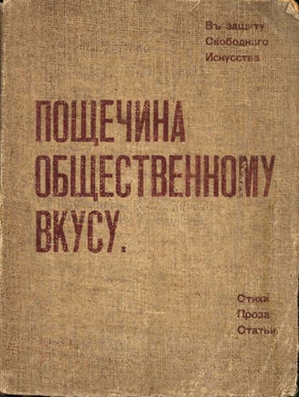 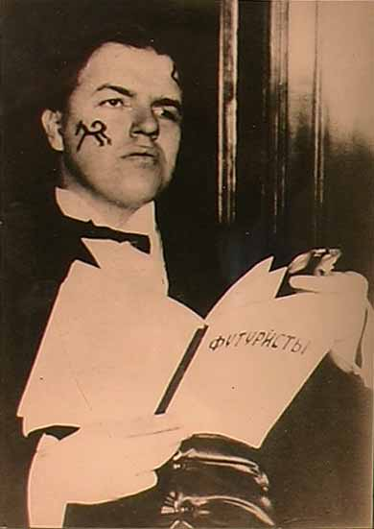 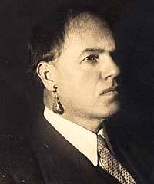 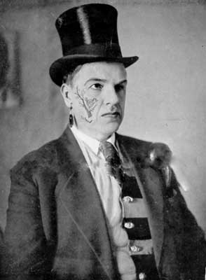

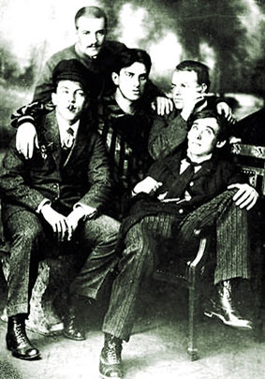 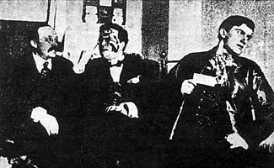 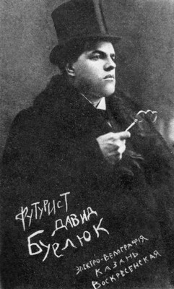

**References and Further Reading:**

Stephanie Barron and Maurice Tuchman (eds.), *The Avant-Garde in Russia 1910-1930, New Perspectives,* Los Angeles County Museum of Art, 1980.

First major exhibition of the period presented in the United States. Includes primary documentation, scholarly essays, biographical material for David and Vladimir Burliuk, among others.

Vahan D. Barooshian, *Russian Cubo-Futurism 1910-1930*, The Hague, Mouton, 1974.

Chapter 3 deals at length with David Burliuk narrating all the major historical events associated with him.

John E. Bowlt (ed.), *Russian Art of the Avant Garde,* *Theory and Criticism 1902-1934*, New York: Thames and Hudson, 1988.

Primary documents by leading artists of the period, including Burliuk’s, translated into English.

Benedikt Lifshitz, *The One and a Half-Eyed Archer*, transl. John E. Bowlt, Newtonville, Massachusetts, 1977.

A first-hand memoir-history of the movement with lots of unique insight into the personal affairs of the members of the group including Burliuk.

V. Markov *Russian Futurism: a History,* Berkeley, 1962.

A major history of the movement still very relevant for any student of the Russian avant-garde.

National Art Museum of Ukraine*, Ukrainian Modernism 1910-1930*, Khmelnytsky: Halereia, 2006.

Major exhibition situating Ukrainian avant-garde artists – such as David and Volodymyr Burliuk - within the modernist sphere.

Noha, Oles. *Davyd Burliuk i mystetstvo vsesvitnohoavanhardu*, Lvyv, 1993.

Arguably, the first biography of David Burliuk to consider his life and work in a Ukrainian cultural and historical context. In Ukrainian.

Yevgenia Petrova (ed.), *Russian Futurism and David Burliuk, ‘The father of Russian Futurism’,* translation from the Russian Kenneth MacInnes, St. Petersburg, Palace Editions, 2000.

This is a main English collection of materials related to David Burliuk.

Shkandrij, Myroslav, (ed.), *Futurism and After: David Burliuk*, 1882-1967, Winnipeg, Winnipeg Art Gallery, 2008.

The collection features the artistic works of Burliuk throughout his entire career as a painter. This collection travelled to New York and the Ukrainian National Museum, where the catalogue was published as:

Ukrainian National Museum, *Futurism and After David Burliuk 1882-1967*, New York; The Ukrainian Museum, 2008.

**Dennis Ioffe, University of Ghent**

**Adrienne Kochman, The School of the Art Institute of Chicago**

Source urls for images:

Portrait by Vassily Kamensky, The Russian Museum, 1916.

Wiki photo Url:  <http://en.wikipedia.org/wiki/File:Burliuk_Kamensky.JPG>

Revolution, 1917.

Wiki photo: <http://en.wikipedia.org/wiki/File:Burliuk_Revolution.jpg>

Cover of Russian Futurists' book "A Slap in the Face of Public Taste", 1912

Wiki photo Url:

<http://commons.wikimedia.org/wiki/File:A_Slap_in_the_Face_of_Public_Taste.jpg?uselang=ru>

Burliuk's photo-portrait, author unknown:

Url: <http://dic.academic.ru/pictures/enc_biography/m_29071.jpg>

Burliuk's photo-portrait, author unknown:

Url: <http://www.bibliotekar.ru/kBurluk/index.files/image001.jpg>

Burliuk's photo-portrait, author unknown:

Url: <http://www.hrono.ru/img/pisateli/burluk.jpg>

Aleksey Kruchenykh, David Burliuk, Vladimir Mayakovsky, Nikolai

Burliuk, Benedict Lifshitz, author unknown:

Url: <http://www.runyweb.com/uploadfiles/image/David_Burliuk_left1.jpg>

Shemshurin, Burliuk and Mayakovsky, author unknown:

Url: <http://ic.pics.livejournal.com/marina_klimkova/50395609/818825/818825_600.jpg>

Burliuk's photo-portrait, author unknown:

Url: <http://wikilivres.ru/%D0%A4%D0%B0%D0%B9%D0%BB:David_Burliuk_Futurist_1910s.jpg>